

Solution Architecture

Date | 30 SEPT 2026
Team ID | SWTID-2026-9948
Project Name | EduGenie – AI Learning Assistant
Maximum Marks | 5 Marks

Solution Architecture Diagram:
EduGenie follows a modular three-tier architecture comprising Presentation Layer, Application Layer, and Data Layer.
Students interact with the platform through a responsive web dashboard.
The application processes requests through FastAPI services, communicates with Gemini AI, and stores educational records inside SQLite databases.

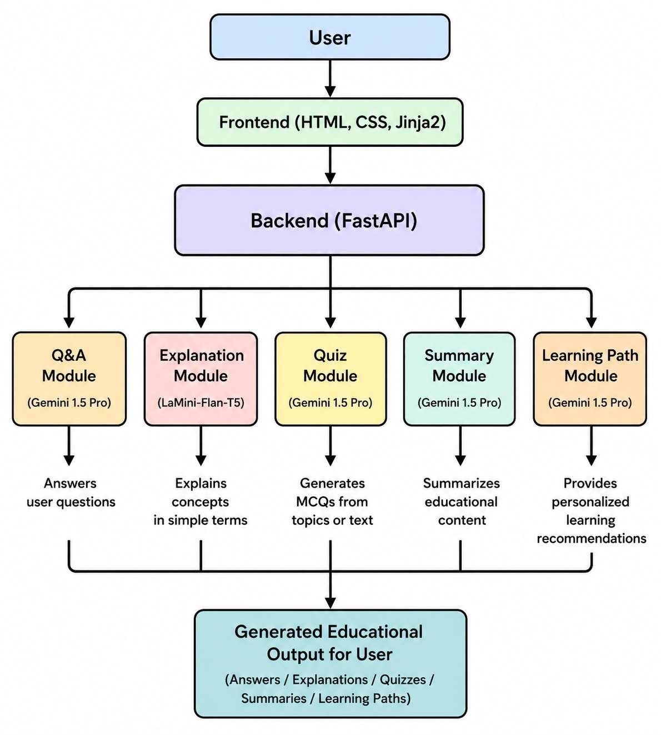



Architecture Layers
Presentation Layer
Student Dashboard
Authentication
Quiz Interface
Q&A Interface
Roadmap Builder
Summarizer
History Section
Analytics
Technology
HTML
CSS
JavaScript
Jinja2

API Gateway
FastAPI
JWT Validation
Authentication
Request Handling
Session Management

Core Logic Service
Gemini API
Quiz Engine
Summarizer
Q&A Engine
Recommendation System
Roadmap Generator
Analytics Service

External Services
Gemini API
Google AI Services
Authentication Services

Data Layer SQLite
User Profiles
Learning History
Quiz Records
Summaries
Roadmaps
Analytics

Component Description Table
Component | Role | Technologies
Presentation Layer | User Interface | HTML CSS JS  Jinja2
API Layer | Handles Requests | FastAPI
Authentication | Secure Access | JWT
AI Services | Educational  Intelligence | Gemini API
Recommendation  Engine | Personalized  Suggestions | Python
Database | Data Storage | SQLite
Analytics | Learning Insights | Chart.js
History Module | User Records | SQLite

Architecture Diagram Labels
Presentation Layer
↓
EduGenie Dashboard
↓
FastAPI Gateway
↓
Authentication Service
↓
Gemini AI Engine
↓
Q&A Service
↓
Quiz Generator
↓
Summarizer
↓
Roadmap Builder
↓
SQLite Database
↓
User Learning History
↓
Analytics Dashboard

